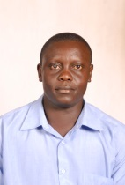

Alex Nabiswa

Team Leader

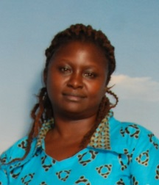

Program Coordinator, Youth & Women

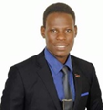

Dr Moses Wakenya

Instructor, Health Data science